Great Hotels of the World proudly announces new members in three exciting destinations for 2019
(London, January 2019): Great Hotels of the World, the established hotel representation group, has announced four new member hotels joining their upscale hotel collection in time for 2019, in three exciting destinations – with three hotels across Portugal and one in Rio de Janeiro, marking their first investment into South America.
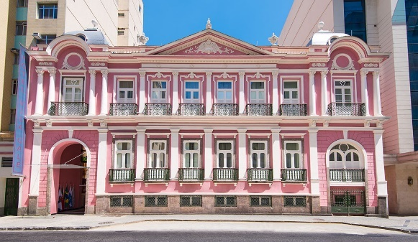
Rio de Janeiro
Located in the city’s bohemian neighborhood of Bairro de Lapa, Vila Galé Rio de Janeiro is a distinctive 19th century old palace house which masterfully combines old world charm with modern day elegance mirroring the rhythm, spirit and effortless charm of Rio de Janeiro. With a magnificent outdoor swimming pool as its centerpiece, the hotel offers 292 rooms, flooded with natural light, as well as the modern Satsanga spa with gym, massage room and Jacuzzi. Guests can enjoy local cuisine with four restaurants and bars to choose from, with the option to step out onto the lively streets and enjoy the energetic restaurants and bars for which Lapa is so famous.
Hot To-Do Tip: Once a week, the relaxed ambience of Lapa takes over Vila Galé Rio de Janeiro in the form of a highly regarded jazz night in the hotel’s Vinicios de Morais bar, enjoyed by guests and local jazz aficionados.
Lisbon
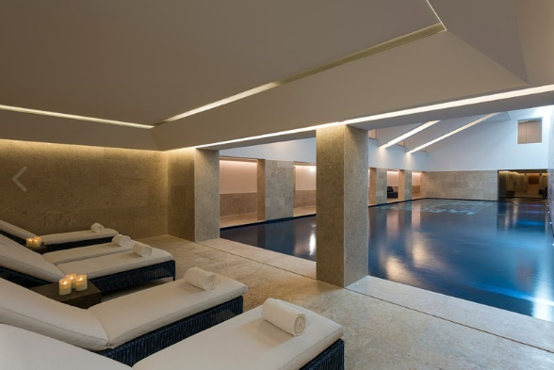
At Nau Palácio do Governador in Lisbon, centuries old history meets contemporary luxury in this charming boutique hotel. Located in Belem, one of Lisbon’s most illustrative and exciting neighborhoods, this former residence of the Tower of Belem’s Governor, has been expertly remodeled into a beautiful 60-room boutique hotel. Visit the sensational spa and take a dip in the swimming pool, tucked away from the hustle and bustle of the Portuguese capital.
Hot To-Do Tip: Travellers with a passion for history will be delighted by some of the elements that were salvaged during the works and have been incorporated into the design of the hotel, including the remains of a 16th century chapel that was a part of the residence of the Governors of the Tower of Belem; restored ceramic tiles on display in the lobby; and what appears to have been a fish sauce factory dating from Roman times, from the 1st to the 5th century AD.
The Algarve
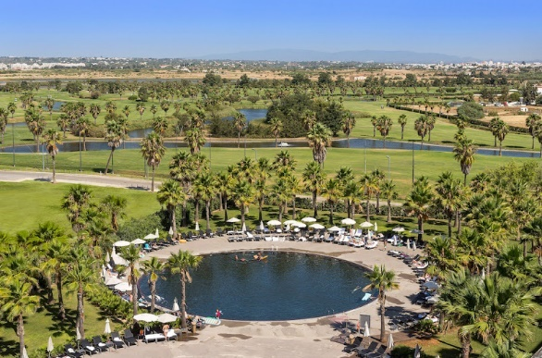
A haven for golfers and home to some of Europe’s most pristine coastline and golden beaches, Nau Salgados Palace in the Algarve is a classic year-round destination. The ocean blue of Portugal’s southern coastline and the deep green of the adjacent golf courses are the striking colours that envelope Nau Salgados Palace. Enjoy four round swimming pools surrounded by palm trees, drinks at Sunset Bar while the sun sets and two restaurants serving local cuisine.
Hot To-Do Tip: The magnificent Salgados Lagoon – Nature Reserve is a treat for nature enthusiasts, and an exciting birding hotspot. Locals and experts alike say that dusk is the best time to spot the greatest variety of birds, which may include such rare species as the Crested Cook and the Spoonbill in migratory season to flamingos and bluethroats. Take a walk along the boardwalk that runs along the lagoon and parallel to the beach offering breathtaking views.
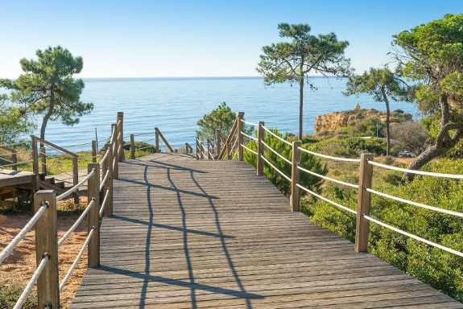
With 149 contemporary well-appointed rooms overlooking the Atlantic Ocean and gorgeously landscaped grounds, the Nau São Rafael Atlântico offers guests incredible views, Mediterranean cuisine, three large outdoor pools, a gym and a world class spa offering the latest therapies and treatments – just steps away from one of the best beaches in Southern Portugal.
Hot To-Do Tip: Some of the world’s leading athletes, models and movie stars swear by the raw food diet. Now, guests staying at the Nau São Rafael can enjoy an entirely raw diet at the recently opened Raw Food Bar, where Japanese style raw cuisine is prepared in a live cooking show by famed sushi man Carlos Queiroz and can be ordered to go.
“We are delighted to welcome these stunning hotels to Great Hotels of the World”, said Pedro Colaco, CEO of the company. “The addition of these hotels in three coveted destinations confirms that Great Hotels of the World is the brand of choice for forward thinking hoteliers who understand the benefits of a global brand offering global marketing services, MICE and Corporate Sales and branded GDS connectivity - all supported by our leading technology. These new hotels, in Rio de Janeiro, Lisbon and the Algarve continue to represent the finest in independent, characterful hotels in the world.”
GHOTW is a well-established sales and marketing hotel representation company for upscale independent hotels, specializing in business and leisure travel. GHOTW enjoys a strong footprint in not only Portugal, but also in Croatia, Turkey, the UAE, and more.
Press information:
Mango PR: +44 (0)207 421 2500
alexandra.hirst@mangopr.com | lara.good@mangopr.com

About Great Hotels of the World (GHOTW)
GHOTW is a well-established hotel representation company which provides global hotel sales and marketing services, as well as innovative technology solutions for an exclusive portfolio of some 60 primarily independent hotels and resorts worldwide. Just as each hotel is unique, so are the tailored sales and marketing products and services that GHOTW provides to each one. This highly personal approach ensures that each hotel retains its personality and authenticity while accessing state-of-the-art technology, distribution channels, and new source markets. GHOTW has operations in London, Madrid and Lisbon.
For more information, please visit www.ghotw.com
About GuestCentric
GuestCentric is the leading provider of cloud-based digital marketing software and services that help extraordinary hoteliers enhance their brands, drive direct bookings and connect with their customers and on all digital platforms. GuestCentric’s award-winning solution provides hoteliers with the only unified solution for managing hotel guests’ online journey: custom-built responsive web sites for mobile, tablets and desktops; an integrated booking engine; a social marketing module to publish deals on Facebook, Twitter and other social networks; and a channel manager to offer rooms on Booking, Expedia, TripAdvisor, Google and hundreds of other channels. GuestCentric has operations in New York, San Diego, London, Barcelona and Lisbon, and is a proud partner of hotels that are part of collections like Great Hotels of the World, Design Hotels, Small Luxury Hotels, Leading Hotels of the World, Relais & Chateaux and VOILA Hotel Rewards.
For more information, please visit https://www.guestcentric.com/

